guys pls change the chat to "All panelist and attendees" from "All panelist"

Because even we might have same doubt or ques.

@Jasmeet Singh

Skewness and Kirtosis

Covariance and Correlation

introduction to python

**Skewness**

First is left skewed, centre is normal distribution, last is right skewed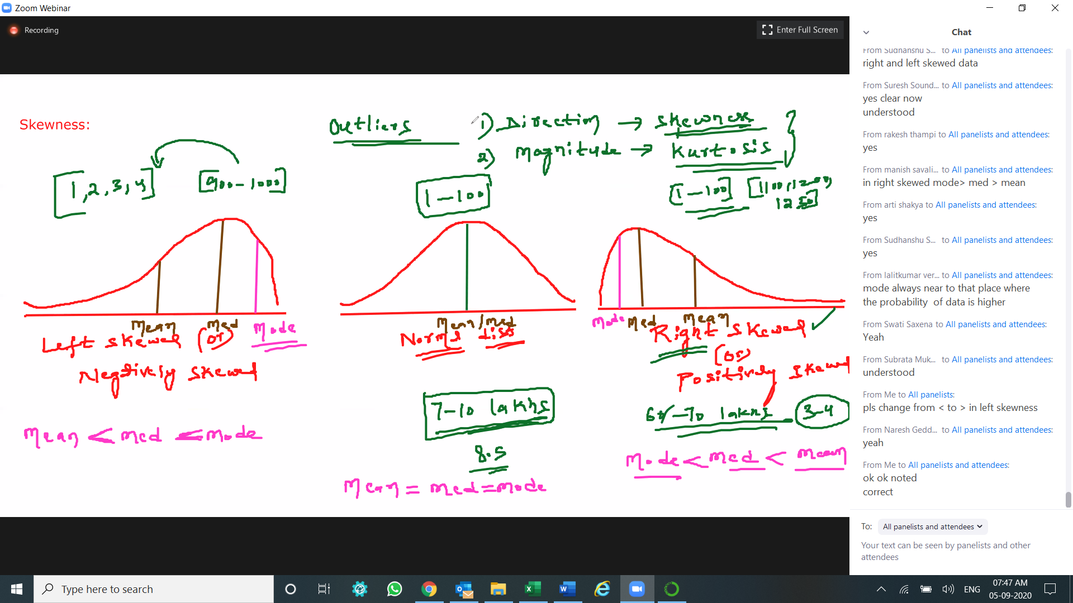 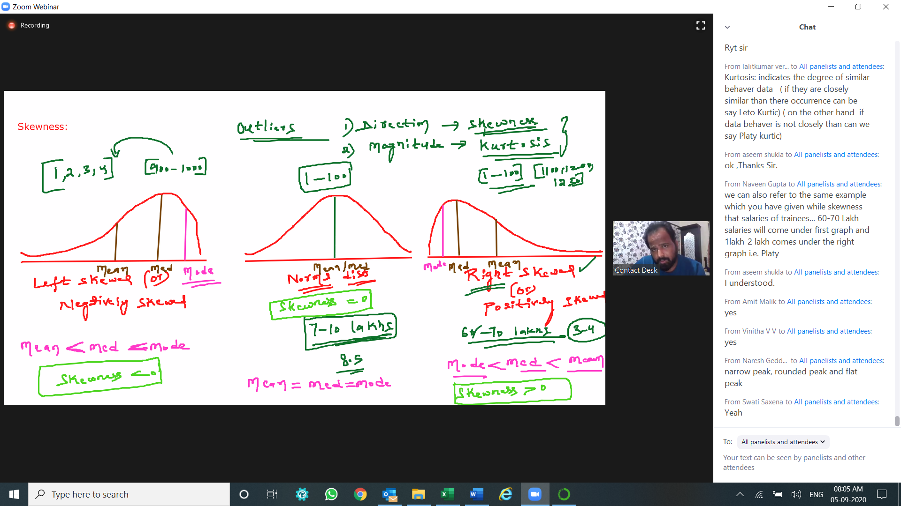

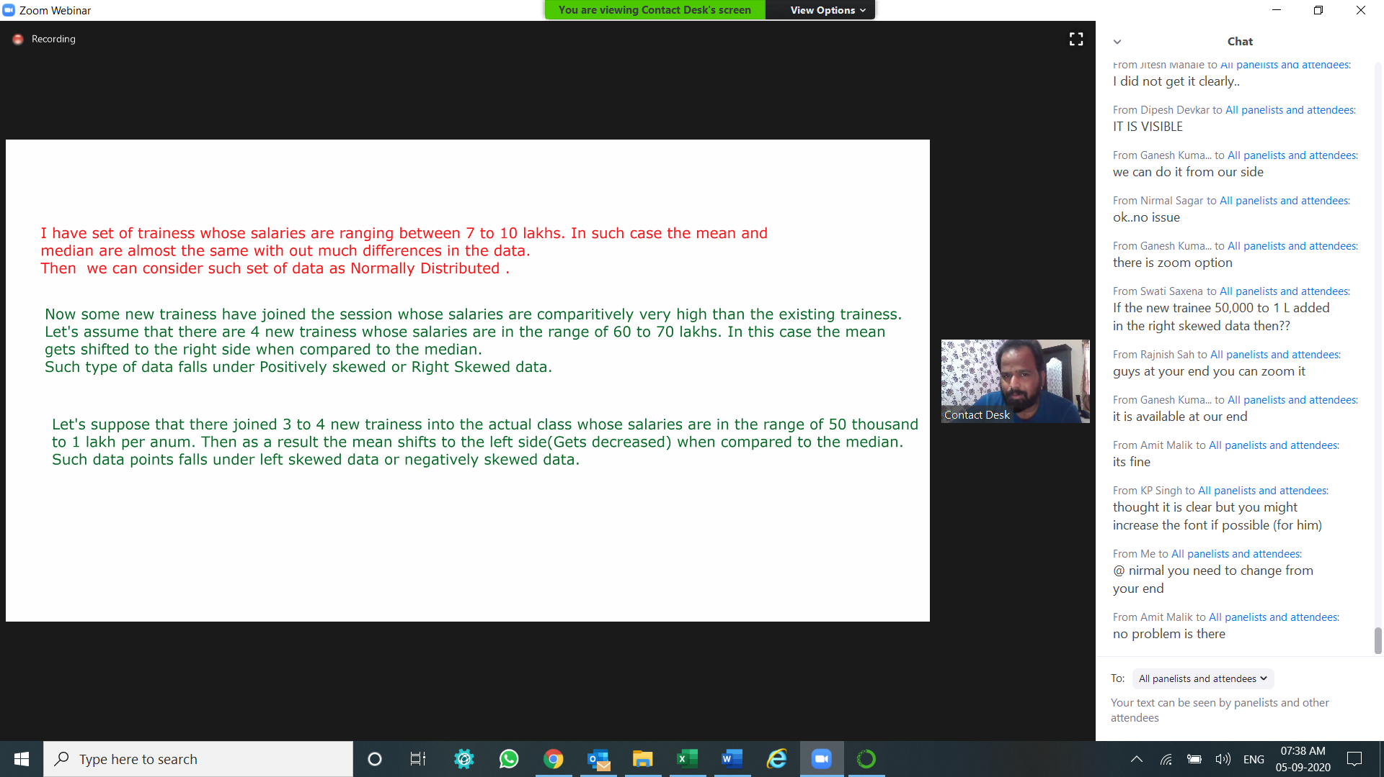

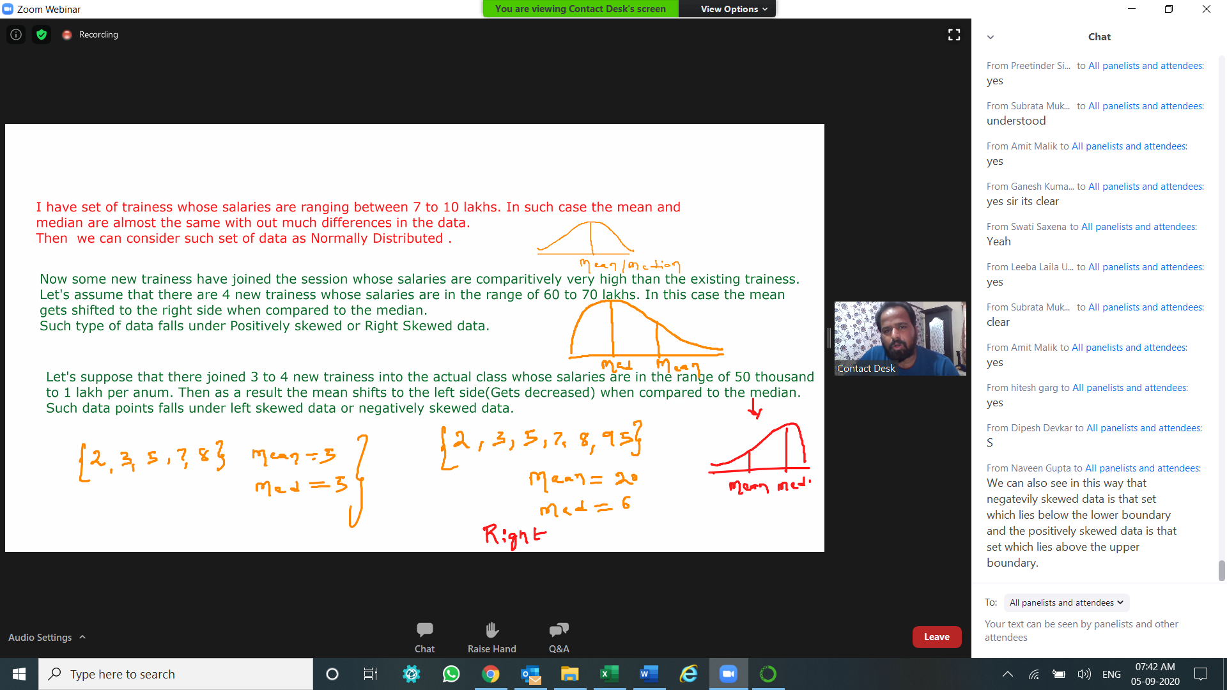

**Kirtosis**

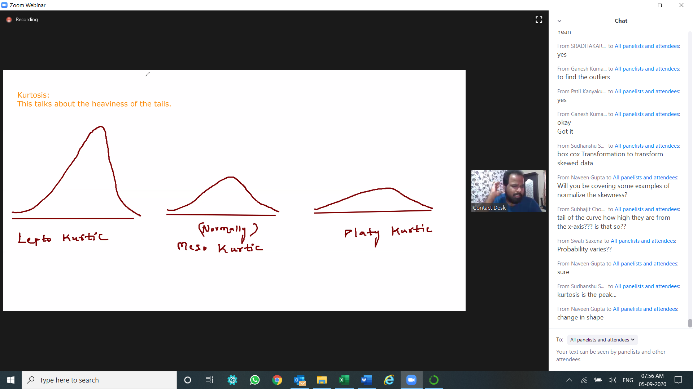

Eg,. 1

Lepto Kurtic is share investing, FD is normal, MF is Platy kurtic

Eg,. 2

lepto kurtis > now days if your will visit hospital then you are high risk

meso kurtis > stay at home is -no risk

Platy kurtis > visit to market -low risk for getting covid.

Eg,. 3

Meso Kurtic is normally distributed,

Plato Kurtic imply thicker tails and lower peak

Lepto Kurtic imply thinner tails and higher peak

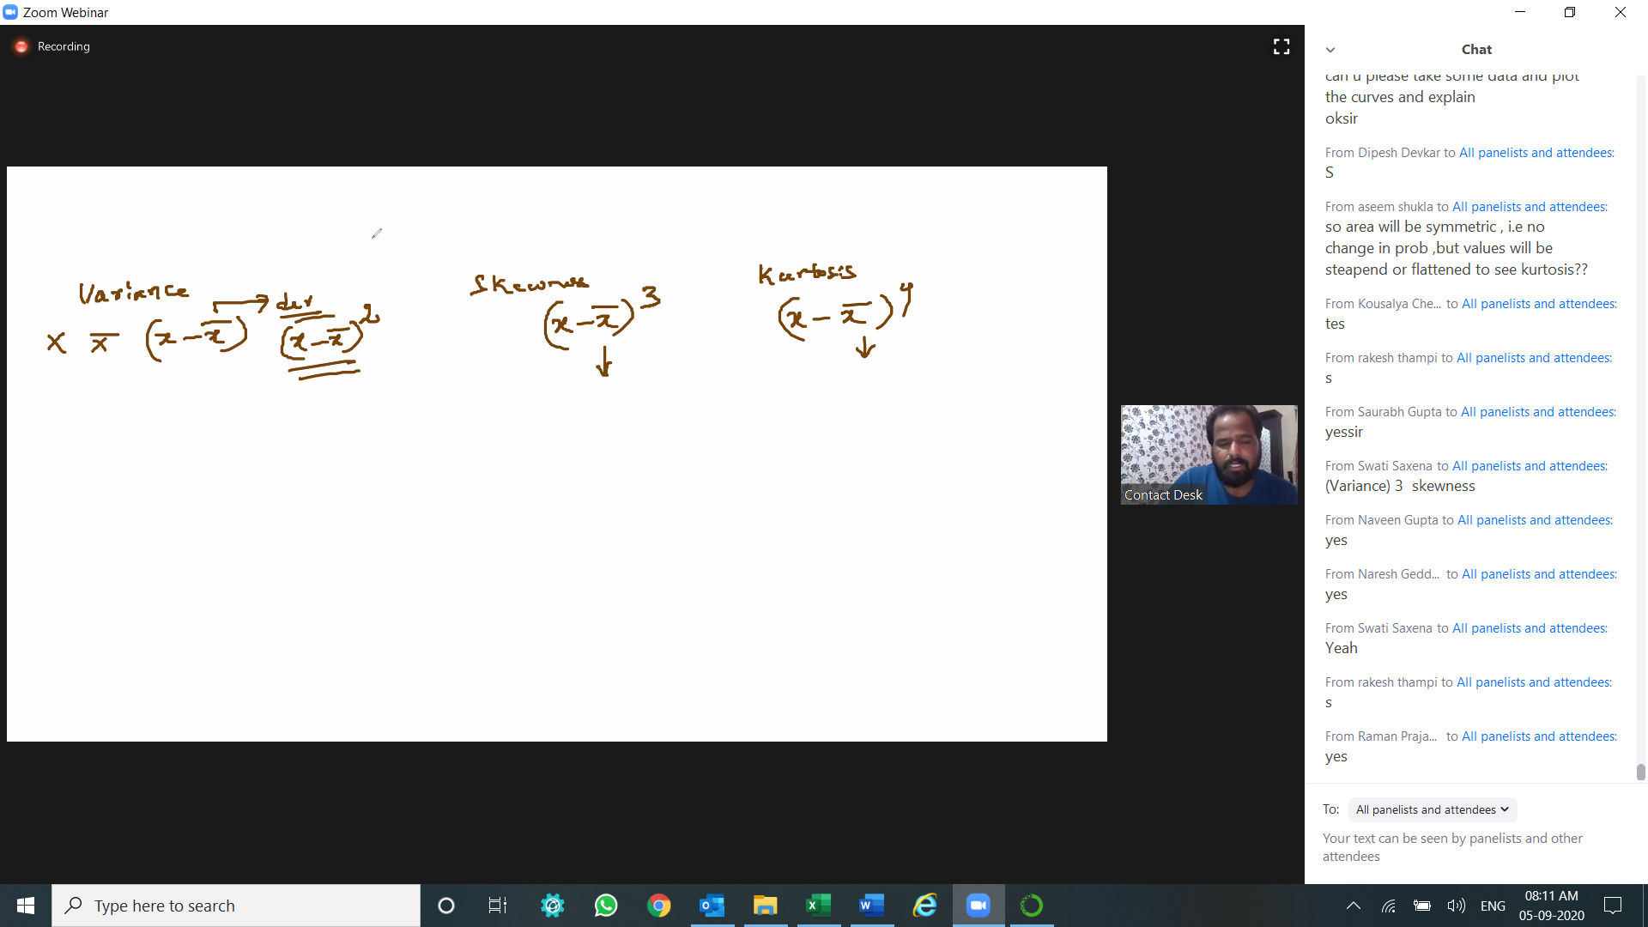

Measures of dispensation

1. Variance - we use 2nd degree

2. Skewness - we use 3rd degree

3. Kurtic - we use 4th degree

**Bi Variate Analysis**

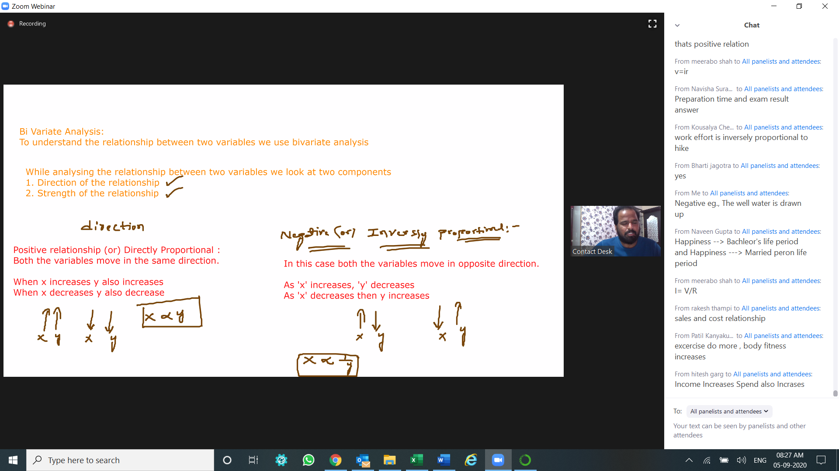

Eg,. 1

Direction Eg,. - If I drive my car @ top speed your vehicles mileage starts decreasing and if I drive the car in economic speed then mileage will increase  
Negative Proportion Example : Road slop Increase - speed of cycle decease

Eg,. 2

Positive Relationship : As no. of people increases food supply increases

Negative Relationship : As resistance of power cable increases then current flow in it is less

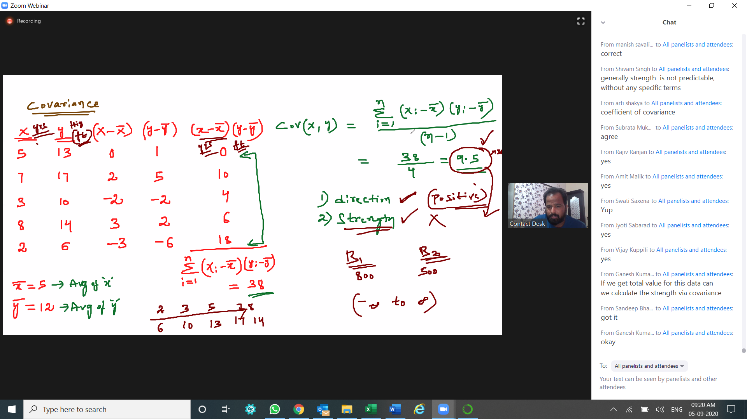

|  |  |  |  |  |  |  |  |  |  |
| --- | --- | --- | --- | --- | --- | --- | --- | --- | --- |
| Covariance | nEi=1 (X:-X|) (Y:-Y|)/(n-1) | | |  |  |  |  |  | Covariance |
| X | Y | X-X| | Y-Y| | (X-X|) (Y-Y|) | | **X** | **5** |  | **nEi=1 (X:-X|) (Y:-Y|)/(n-1)** |
| 5 | 13 | 0 | 1 | 0 |  | **Y** | **12** |  | **9.5** |
| 7 | 17 | 2 | 5 | 10 |  | **nEi=I** | **38** |  |  |
| 3 | 10 | -2 | -2 | 4 |  | **n** | **5** |  |  |
| 8 | 14 | 3 | 2 | 6 |  | **(n-1)** | **4** |  |  |
| 2 | 6 | -3 | -6 | 18 |  |  |  |  |  |

